## CSD-3184 Mobile Development -Term Project

## Team Name: J

Team Members :

Gurjot Singh Chadha(C0735957)

Kirandeep Kaur(C0740003)

Paras Kumar(C0737465)

Page 1, landing page. User Must login first to get access to the app using the registered username/password via SqlDatabase.

Landing page

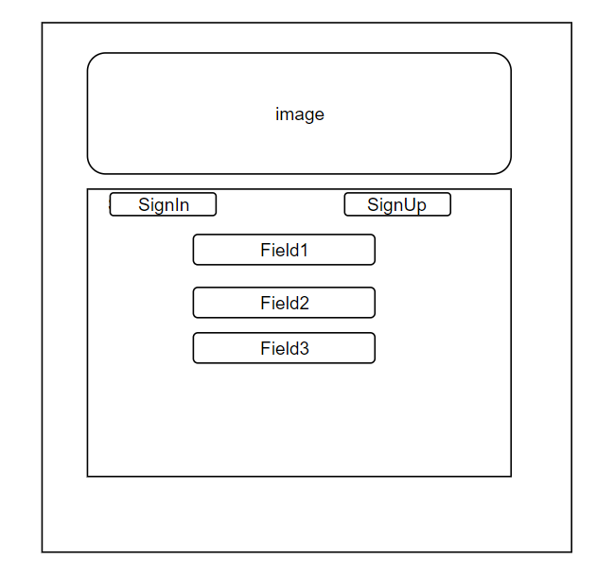

Page 1.2: registration Tab.

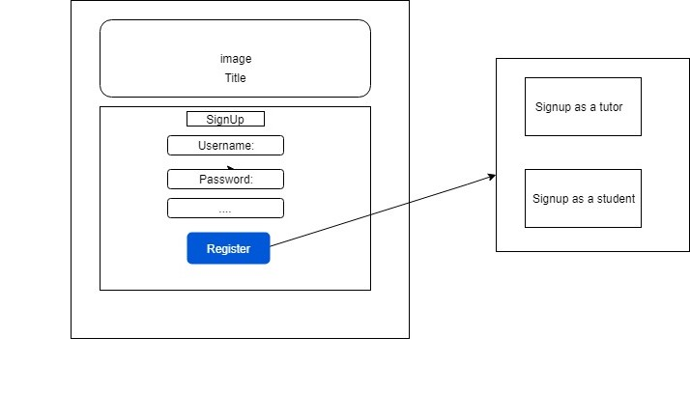

Page 2, Profile page: The first page any student/tutor sees is his profile. Tutor gets to see his rating, pay rate etc. while the student profile gets extra options to open search page for tutors.

Profile Page

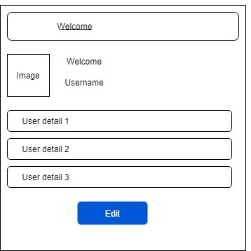

On page 2.2, Discover Tutor(For Student): Student can make use of search page to search tutors that match required criteria – name, subject, language, distance etc.

Discover Tutor

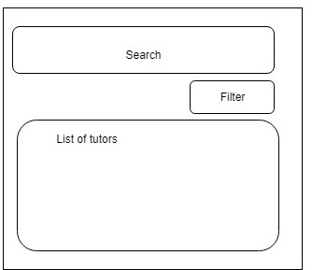

Page 3, Favourite Tutor List (For Student Profile): Students can save tutors they have already studied with or file reports against tutors for misconduct.

Favorite Tutor List

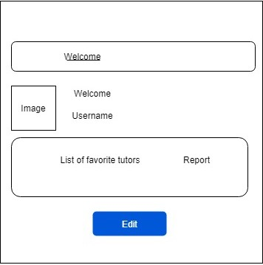

Page 4, Admin Panel: For System Admins, this page gives access to the profiles sent for verification or reported profiles.

